Area Formula

Find the radius of the area ( dot from center of the circle to the one edge)

Radicus=r

Let say r= 6cm

A=Area= pi* r*2 (r*2= square root of r i.e. 6)

r=6

r2=62  = 6*6=36

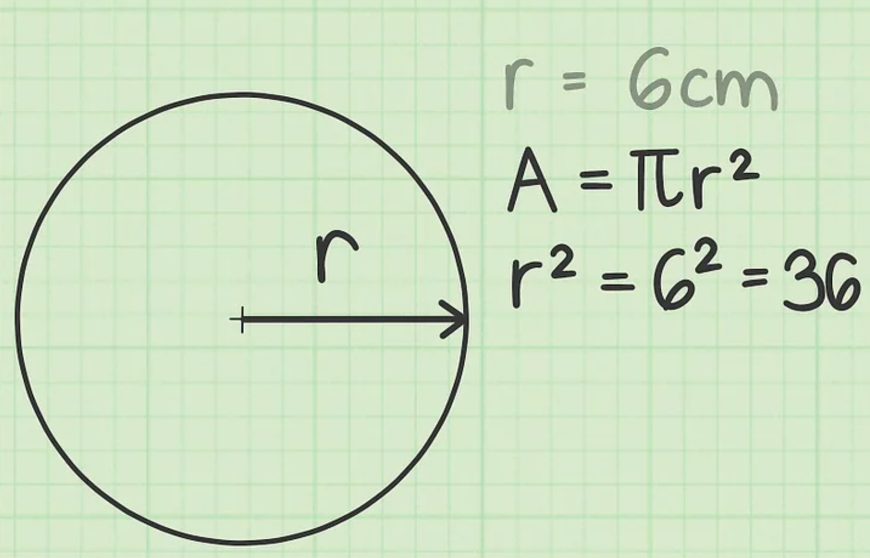 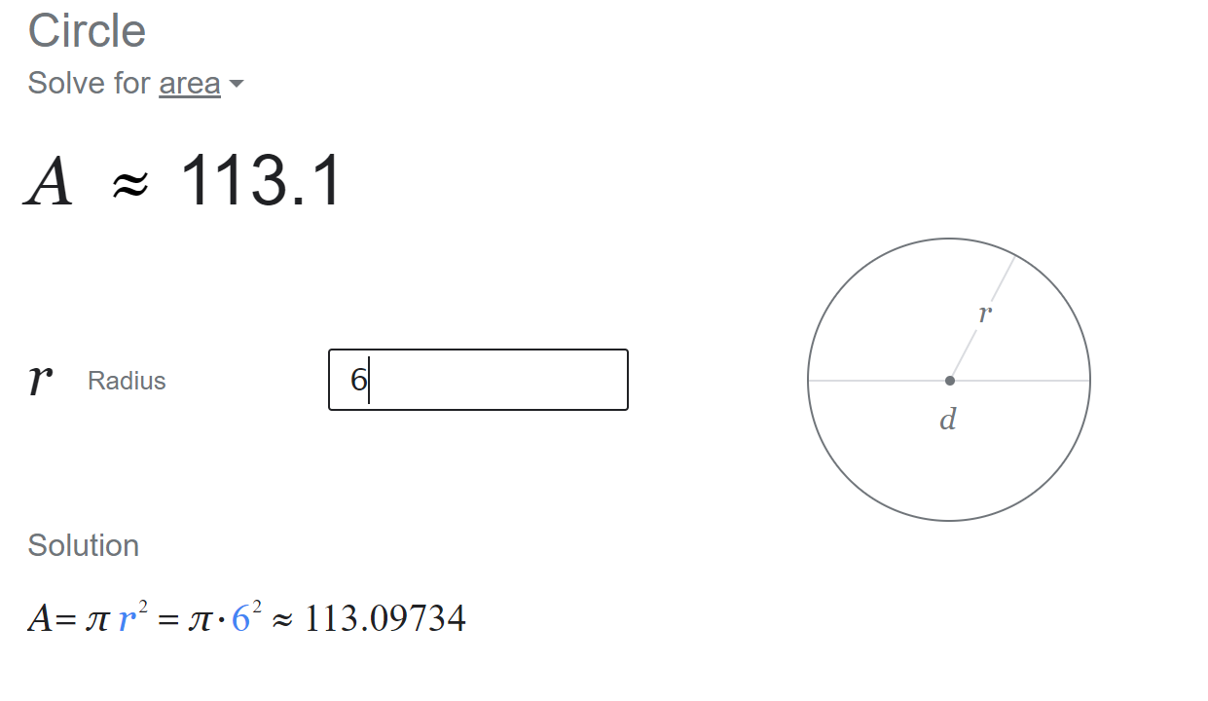

**Java coding challenge:-**

Write an algorithm to create class **Area**and find area of the circle using final keyword for **pi**value.

After writing the algorithm, write suitable code, run the program, and check the output.

**Algorithm:-**

1. **Create a class Area;**
2. **Declared data members and Variables**
   1. **int r (to store the initial value )**
   2. **int radius( to store the square root value)**
   3. **“Final” float pi- using final keyword**
   4. **float totalArea;**
3. **Import the java.util.Scanner;**
4. **Initialize the Scanner to take the user input value;**
5. **Use SOP to print the calculation on output**
   1. **Int radius = (r*r)**
   2. **totalArea = pi*radius**
6. **end of coding with curly braces closure.**